Name: Krish Agarwal

Register Number: 21112016

Class: 5BSc DS

Full Stack

**CIA Assignment: Module 1**

Q1) Create a landing page i.e. home page for college website with different sections like home, about us, contact us, courses (add a dropdown), login & sign up, you can refer your college or any other landing page for the same.

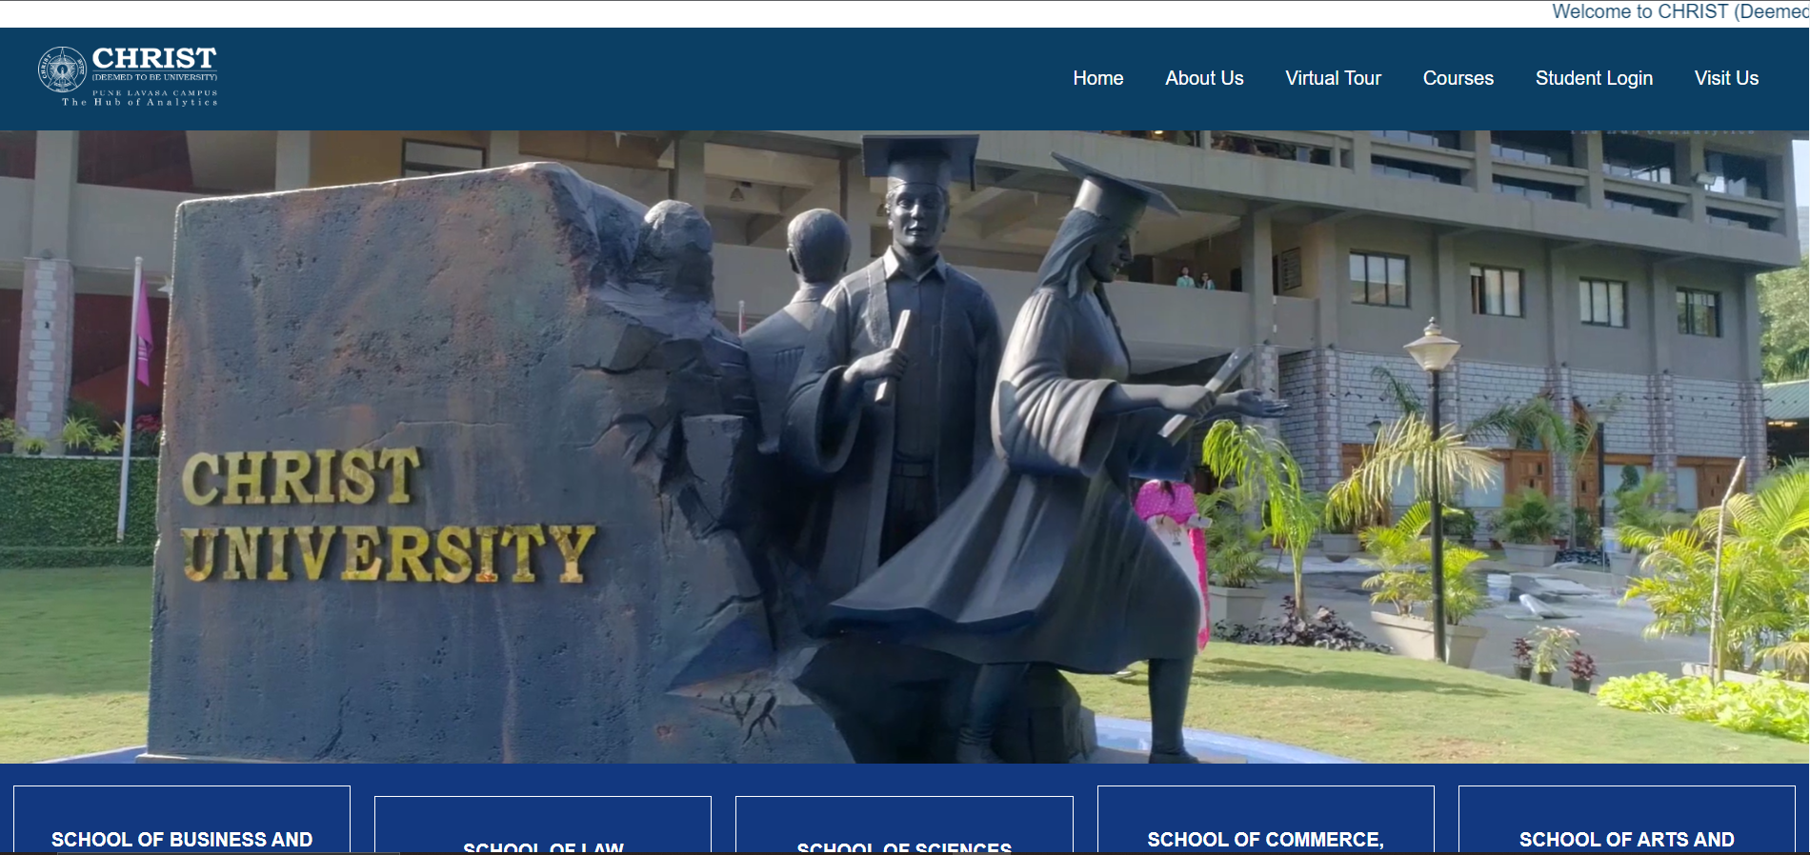

Q2) Create a registration page and once clicked on submit button, a mail should be sent to your email ID with all the details that you have registered successfully.

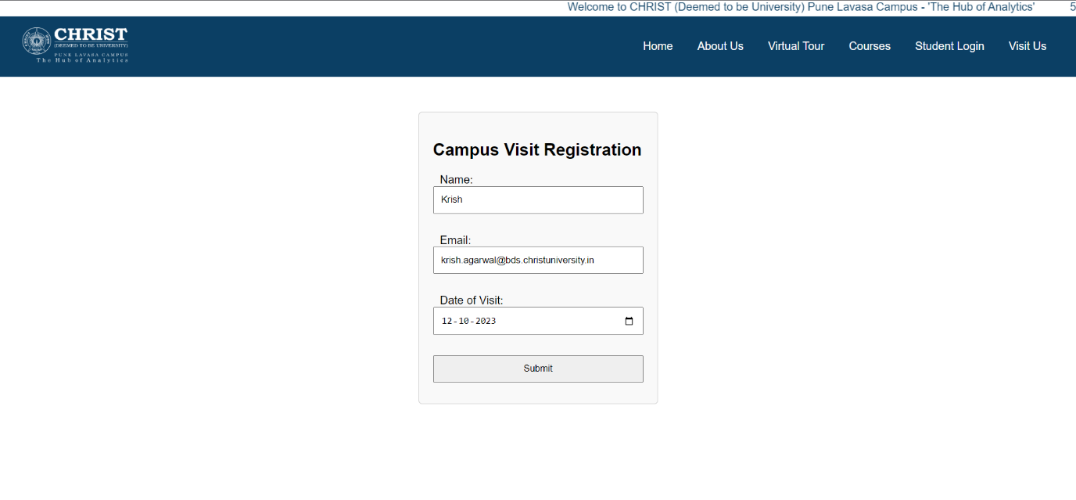

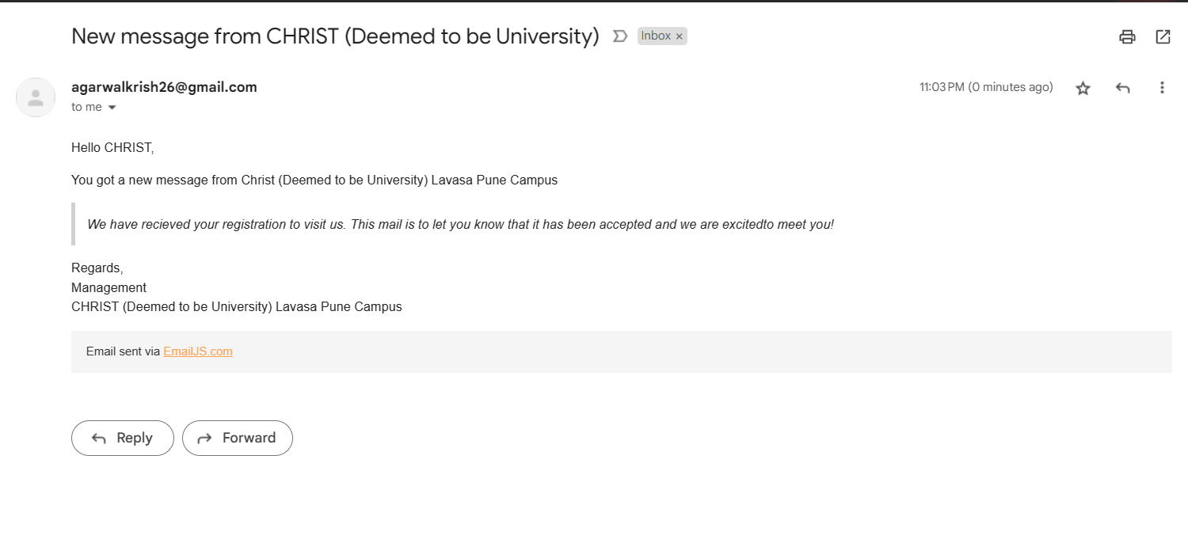

Q4) Create a page for cars using HTML, CSS & JavaScript, the car names should display the car model image with all its details. Choose any 3 cars and add sound (exact sound of the car model) once you hover on the car image.

Once clicked on buy, it redirects you to another page with the invoice of that particular car.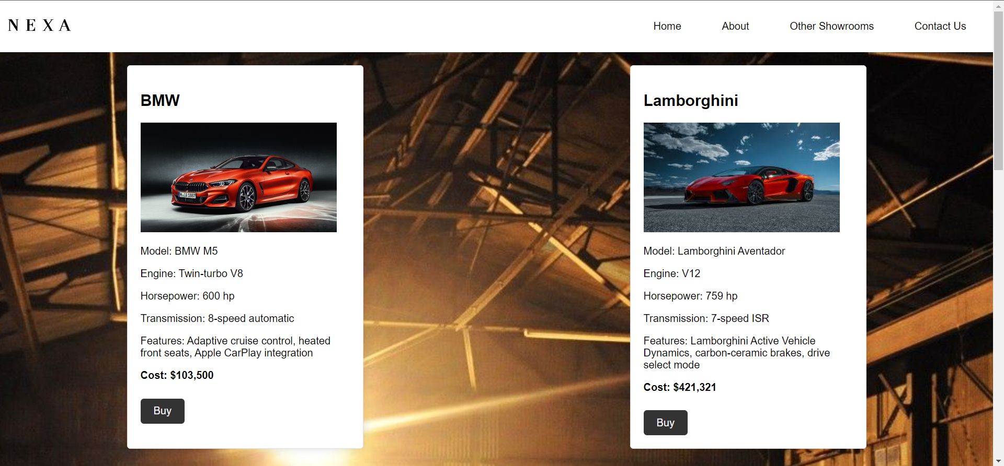 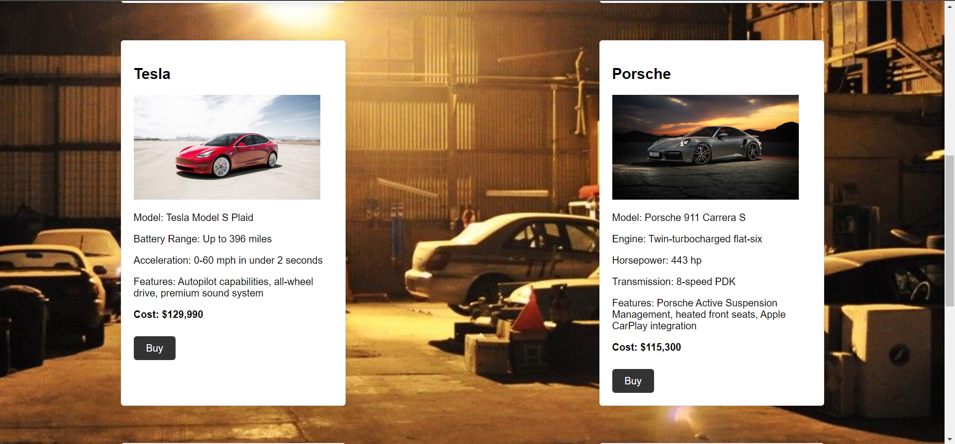 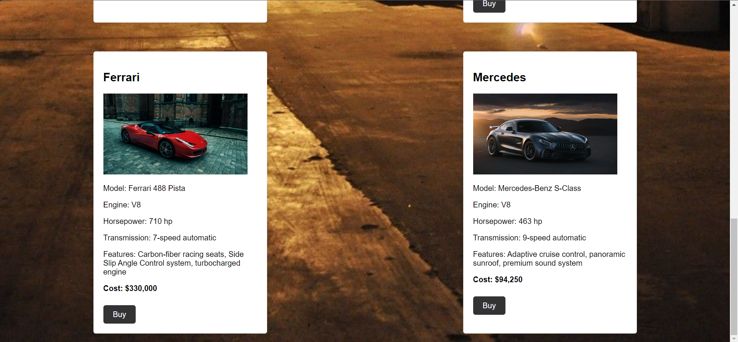

Q3) Create an invoice receipt using HTML, CSS for any products you have purchased.

